sorting algorithms

advantages and disadvantages

# Introduction

Before discussing three different sorting algorithms, first discuss big O natation which in computer science is the way to describe the performance or complexity of an algorithm. This can describe the execution time required or the space used by the algorithm. Big O natation is represented by an O followed by brackets containing either a number or the letter N. N represents the number of items in a list or an array.

Example one, O(1). This means the algorithm will always execute in the same time or space regardless of how many items in the list. Example two, O(N). This means the algorithm whose performance will grow linearly, depending on the size of the list. For a more visual look on big O natation and on what is considered as good or bad view Appendix A below.

# Bubble Sort

The bubble sorting algorithm is one of the most common sorting algorithms. It works by repeatedly swapping adjacent elements that weren’t in order until the items are in sequence. (Shown in Appendix B) A good way to explain bubble sort is the following: “You can imagine that on every step the big bubbles float to the surface and stay there. At the step, when no bubble moves, sorting stops” (*Bubble Sort*. Retrieved from algolist, 2009).

The main advantage of bubble sort is that it is easy to implement and understand. Therefore, it’s primarily suitable for teaching but not for real-life applications. The elements are swapped in place without using more temporary storage.

The disadvantage is that this sort can’t deal well with large sets of data. The sort also requires O(n2) processing steps for every n number of elements so that it can be sorted.

# Pancake Sort

The idea of the pancake sort is to sort a disordered stack of pancakes in order of size by using a spatula to insert at any point in the stack and flipping all of the pancakes above it. This means that it is trying to order the elements by flipping the largest element to the end of the list then repeating until the list is in ascending order. (Shown in Appendix C)

The main disadvantage of pancake sort is that it’s not the quickest solution. The memory and run time that is required is O(n) and O(n2). Due to the data that I obtain by *Austin, Pancake Sort* it wouldn’t work well sorting a large list.

# Merge Sort

The merge sort works on the principle of divide and conquer. This sort repeatedly breaks down the data into many smaller sets of data. This process is repeated until there is only a single value in the data set. Then the sub lists are merged back together in order. (Shown in Appendix D)

The advantages of merge sort are that it is quicker than other sort algorithm for example bubble sort and insertion sort. This is because merge sort doesn’t loop through the whole list several times.

The disadvantage of merge sort is that this requires more space and is less efficient than other sorts. It uses more space to store the sub elements of the initial list and will be slower when compared to the other sorts for smaller tasks.

# References

algolist. (2009). *Bubble Sort*. Retrieved from algolist: http://www.algolist.net/Algorithms/Sorting/Bubble_sort

Austin. (2014, June 2014). *Pancake Sort: Everyday Algorithms*. Retrieved from austingwalters: https://austingwalters.com/everyday-algorithms-pancake-sort/

bigocheatsheet. (n.d.). *Know Thy Complexities!* Retrieved from bigocheatsheet: https://www.bigocheatsheet.com/

*Interesting Information*. (2014, February 28). Retrieved from blogspot: http://z-sword.blogspot.com/2014/02/advantages-and-disadvantages-of-sorting.html

interviewbit. (n.d.). *Merge Sort Algorithm*. Retrieved from interviewbit: https://www.interviewbit.com/tutorial/merge-sort-algorithm/

*Merge Sort*. (2019). Retrieved from hackerearth: https://www.hackerearth.com/practice/algorithms/sorting/merge-sort/tutorial/

*Merge sort, advantages and disadvantages*. (2019, May 26). Retrieved from getrevising: https://getrevising.co.uk/grids/merge-sort-advantages-and-disadvantages

Rob Bell. (n.d.). *A beginner's guide to Big O notation*. Retrieved from Rob Bell: https://rob-bell.net/2009/06/a-beginners-guide-to-big-o-notation/

Stack Overflow Contributors. (n.d.). *Pancake Sort Basic Information*. Retrieved from riptutorial: https://riptutorial.com/algorithm/example/24754/pancake-sort-basic-information

Wandy, J. (2018, June 27). *The Advantages & Disadvantages of Sorting Algorithms*. Retrieved from sciencing: https://sciencing.com/the-advantages-disadvantages-of-sorting-algorithms-12749529.html

yourbasic.org. (n.d.). *Big O notation: definition and examples*. Retrieved from yourbasic: https://yourbasic.org/algorithms/big-o-notation-explained/

# Appendix

## Appendix A – Big-O Complexity Chart

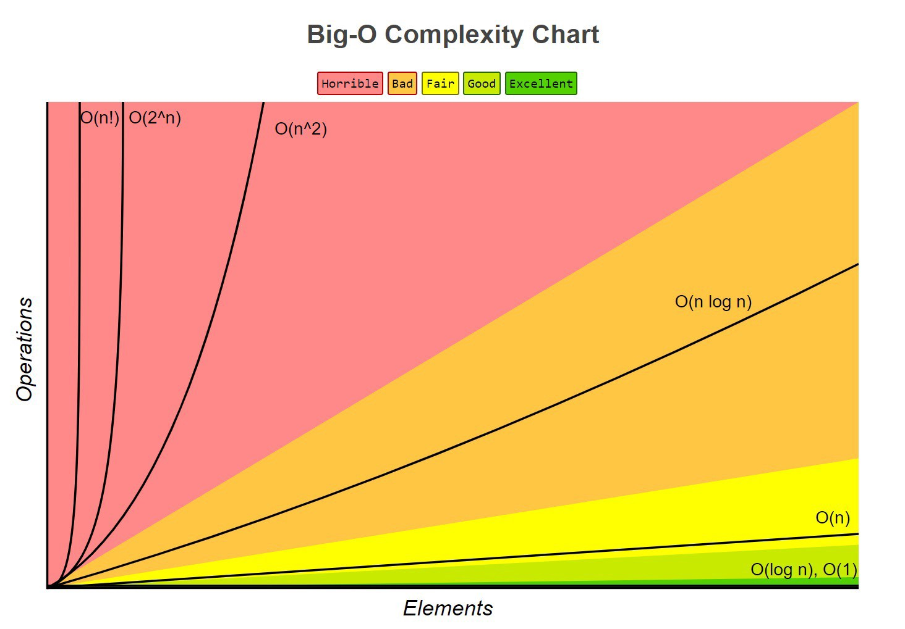

Retrieved from bigocheatsheet: https://www.bigocheatsheet.com/

## Appendix B – Bubble Sort

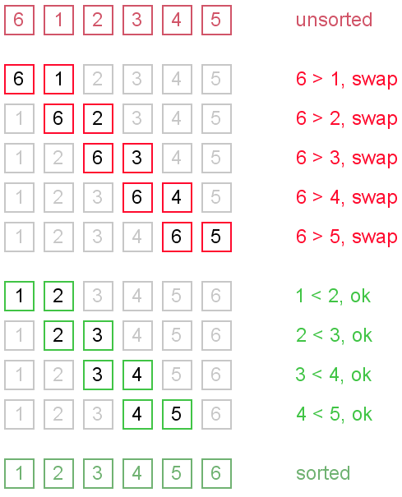

Bubble Sort. Retrieved from algolist: <http://www.algolist.net/Algorithms/Sorting/Bubble_sort>

## Appendix C –Pancake Sort

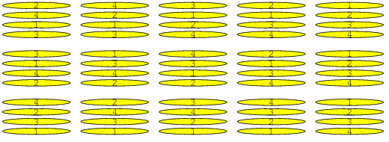

Stack Overflow Contributors. Retrieved from sciencing: <https://sciencing.com/the-advantages-disadvantages-of-sorting-algorithms-12749529.html>

## Appendix D – Merge Sort

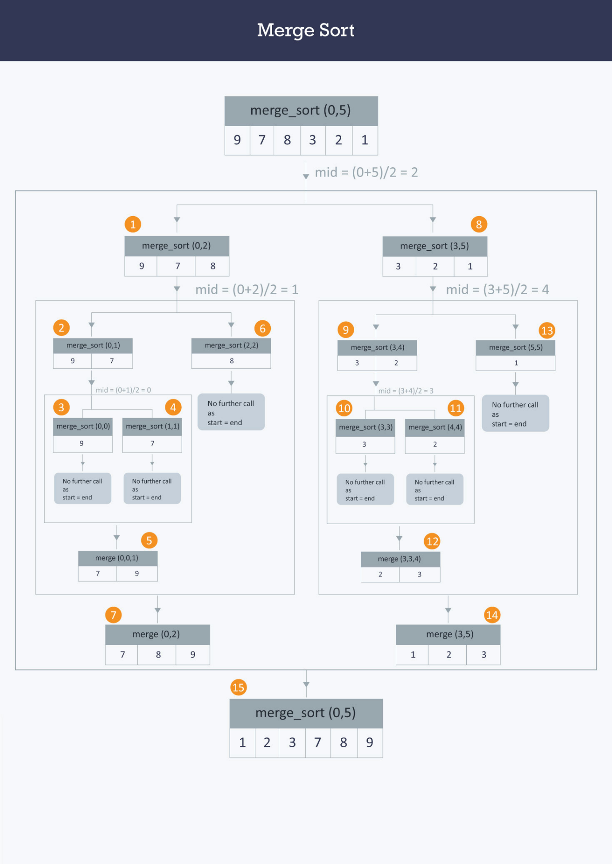

Retrieved from hackerearth: https://www.hackerearth.com/practice/algorithms/sorting/merge-sort/tutorial/